CENWP-OD-B 07/03/12

MEMORANDUM FOR THE RECORD

SUBJECT: Mortalities at Bonneville’s Adult Fish Facility (AFF)

On 03 July CRITFC researchers contacted Project Fisheries to report a dead adult Pacific lamprey and a dead adult female Sockeye found on the Valve 15 trashrack. The fish were released to the tailrace. Information collected is provided below:
- Species – Pacific lamprey (Entosphenus tridentatus)
- Origin – Unknown
- Length – Unknown
- Marks and tags – None
- Marks and Injuries found on carcass – No notable marks or injuries
- Cause and Time of Death – Unknown
- Future and Preventative Measures – Not applicable at this time

- Species – Adult female Sockeye (Oncorhynchus nerka)
- Origin – Not clipped
- Length – 54 cm
- Marks and tags – None
- Marks and Injuries found on carcass – No notable marks or injuries
- Cause and Time of Death – Unknown
- Future and Preventative Measures – Not applicable at this time

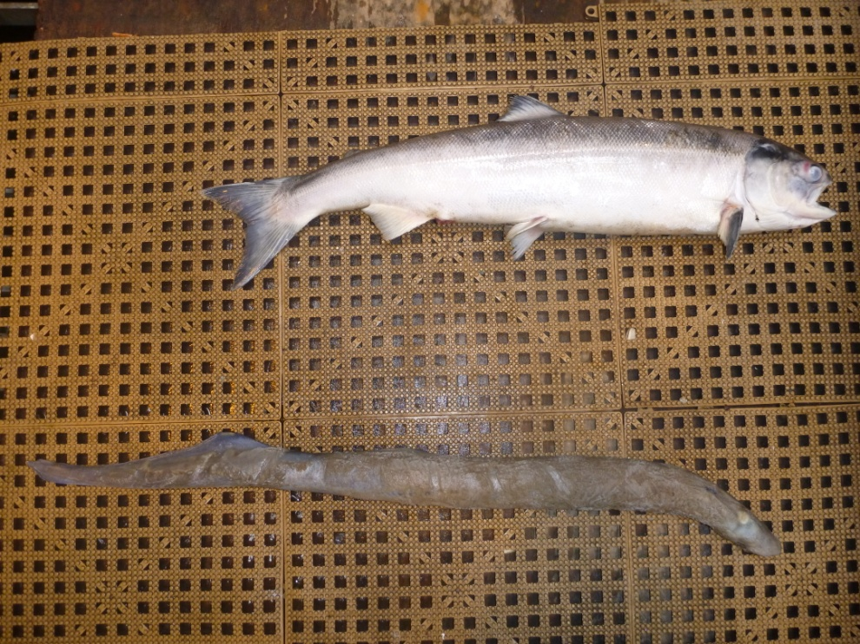

Sincerely,
Bonneville Project Fisheries

